Problem_Set_5

By

**Behrooz Jadidi**

**Student ID: 501001145**

AE/ME8112 - Comp Fluid Dyn/Heat Transfer

**Supervisor:** Prof. Seth Dworkin

Toronto, Ontario, Canada, 2020

© Behrooz Jadidi 2020

**Problem_Set_5 Questions**

1. laminar gaseous flow through a cylindrical pipe of length, *L* and radius *R* with a centerline axial velocity of *CLVZ*.

List of Contents

1 Question_1 1

2 References 2

**List of Figures**

# Question_1

## Part a)

Since the flow is axisymmetric, the problem can be solved as a 2D flow in r and z. Figure ‎1.1 illustrates shchematic of our geometry.

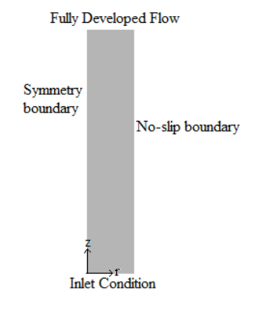

Figure .- Shchematic of 2D geometry

**Assumptions:**

* Axisymmetry
* Constant density
* Constant viscosity
* Fully developed flow at the outflow

Based on these assumptions, the vorticity-velocity equations can be defined as :

|  |  |
| --- | --- |
| $$ρ\frac{∂ω}{∂t}= μ\left[\frac{∂^{2}ω}{∂r^{2}}+\frac{∂^{2}ω}{∂z^{2}}+\frac{∂}{∂r}\left(\frac{ω}{r}\right)\right]$$ | (‎1.1) |
| $$\int_{V}{∇. u dV} =\int_{A}{u.\hat{n} dA}$$ | (‎1.2) |
| $$U_{i+1}A_{i+1} =U_{i}A_{i}$$ | (‎1.3) |

# References

Use the "Insert Citation" button to add citations to this document.